EXPT. NO: 10 | STRINGS
DATE:28.1.2021 | STRINGS
Aim:
To write a C program for the following to
- Check whether given string is palindrome or not without using built-in function
- Find the total number of words
- Capitalize the first word in a sentence
1. Check whether given string is palindrome or not without using built-in function
Algorithm
- START
- GET string
- For i=0 to string[i] != '\0'
- Length++
- FOR i = length – 1 to i >= 0
- reverse_string[length - i - 1] = string[i]
- For flag = 1, i = 0 to i < length
- if reverse_string[i] != string[i])
- Initialize flag = 0
- if flag == 1
- PRINT It is palindrome
- ELSE
- PRINT It is not a palindrome
- STOP
Flowchart
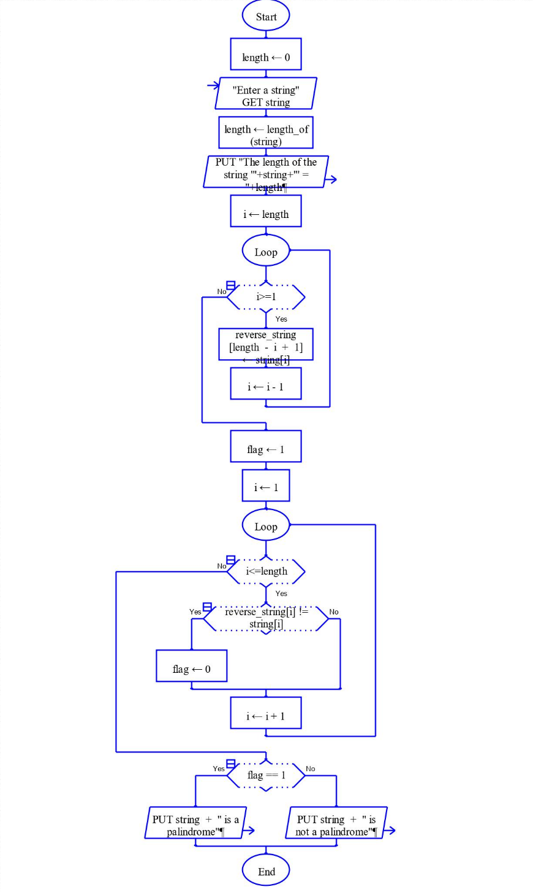
Program
#include <stdio.h>
void main() {
char string[25], reverse_string[25] = {'\0'};
int i, length = 0, flag = 0;

printf("Enter a string \n");
gets(string);
for (i = 0; string[i] != '\0'; i++)
{
length++;
}
printf("The length of the string '%s' = %d\n", string, length);
for (i = length - 1; i >= 0 ; i--)
{
reverse_string[length - i - 1] = string[i];
}
for (flag = 1, i = 0; i < length ; i++)
{
if (reverse_string[i] != string[i])
flag = 0;
}
if (flag == 1)
printf ("%s is a palindrome \n", string);
else
printf("%s is not a palindrome \n", string);
}
Output
2. Find the total number of words
Algorithm
- START
- GET string
- For i=0 to string[i] != '\0'
- IF s[i] == ‘ ‘ && s[i+1] != ‘ ‘
- count++
- PRINT count
- STOP
Flowchart
Program
#include <stdio.h>
void main()
{
char s[200];
int count = 0, i;

printf("Enter the string:\n");
gets(s);
for (i = 0;s[i] != '\0';i++)
{
if (s[i] == ' ' && s[i+1] != ' ')
count++;
}
printf("Number of words in given string are: %d\n", count + 1);
}
Output
3. Capitalize the first word in a sentence
Algorithm
- START
- GET string
- For i=0 to string[i] != '\0'
- IF s[i] == ‘ ‘ && s[i+1] != ‘ ‘
- count++
- PRINT count
- STOP
Flowchart
Program
#include <stdio.h>
void main()
{
char s[200];
int count = 0, i;

printf("Enter the string:\n");
gets(s);
for (i = 0;s[i] != '\0';i++)
{
if (s[i] == ' ')
break;
else
s[i] = toupper(s[i]);
}
printf("%s", s);
}
Output

Result
Thus the C program was written and executed successfully for the following
- Check whether given string is palindrome or not without using built-in function
- Find the total number of words
- Capitalize the first word in a sentence

